Solo: Above or Below the Average?

Introduction:

I distinctly remember seeing Solo play on Clutch in 2018 and thinking to myself “this player is not very good”. It maybe wasn’t a fair assessment, as his competition was about as stacked as NA top lane gets. NA had been on a Top-lane importing spree and contained such Korean superstars as Impact (Season 3 world champion), Flame (of Flame-Horizon fame), and Huni (fresh off a world championship finals appearance). Likewise it was easy to compare him to NA native Hauntzer and rising rookie Licorice and think that maybe this guy wasn’t on an LCS level.

At the start of 2020, Solo wasn’t even on a team, and while people thought this was odd, it wasn’t a decision that earned anything like the vitriol generated by the teamlessness of native NA midlane players Damonte and Pobelter. It wasn’t until the tail end of the 2020 season that Solo was back in a lineup, and he absolutely shocked the world (ok, possibly just me) by being an absolutely monstrous player for his team. I really didn’t remember him being particularly good, but here he was, dragging his team kicking and screaming into the NA LCS finals.

So this begs the question, was Solo always a good player? Or has he been held down by the low tier teams he’s been on? He played as a sub in 2016, a starter in 2018 and 2019, and then in the minor (Academy) league for most of the 2020 spring season. Until 2020’s back to back playoff runs, his main claim to fame had been… that he didn’t take an import spot. In 2021 he managed to take a dead last place GoldenGuardians and make them… slightly better, before being replaced mid-split.

This analysis will concentrate on answering two questions:

1. In the aggregate, has Solo had an above or below average career performance
2. Has Solo improved individually from 2018 to 2021

**Patch and Result stratification**

How a team plays the game has a lot of factors. There might be a player on the opposing team they are looking to shut down, there might be a specific champion combination that allows them to be more/or less aggressive. But often, the way the team plays is dictated by the metagame, which defines the generally available strategies and champions. While a team can choose to play “off meta” and go for some off the wall picks or strategies, it’s just not that common, especially in NA. Unfortunately, it’s hard to take the “meta” into account when looking at statistics, so we’re going to use patch’s to help cover the ‘meta’ factor. Every 2 weeks or so, Riot games releases a new patch, which has the potential to greatly affect the meta. These patches can include champion buffs or nerfs, item buffs or nerfs, and occasionally how xp and gold is collected or achieved around the map.

The week’s patch does a lot to help define the meta, and so it makes sense to use patches to normalize some of the data. I am only going to be using data from patch 8.01 and onward because that is the first patch where Solo was a professional starter. This cuts out some of the noise on reworks and seasonal game changes. If I find that it makes sense to get more granular and group by major patch (8.xx, 9.xx, etc) or even patch to patch, I will do so.

The other way our statistics are going to be grouped is by result. There’s a saying in league that it’s easy for a player to look good on a winning team. Winning teams tend to earn more gold and experience as they snowball a game to victory. It’s rare, for example, that a team wins a game at a gold deficit, or with fewer kills than the opposing team. Some of the best players in the world, however, are known for their gameplay prowess, even on bad or losing teams. So it makes sense to compare player performance both in their wins and losses. Is a player just riding the coattails of their teammates? Or are they the ones making plays and propelling their team to victory?

**Leagues:**

**I’m just going to be looking at the NALCS for this investigation. I want to compare Solo against his peers in order to have the tightest comparative analysis.**

Data of interest.

First off, thank you to Oracle’s Elixer for providing extensive and well-manicured data for us to pull from. I have also expanded that data with my own web scraping. I’d like to thank Riot games for waiting just long enough for me to implement my scraping programs before shutting down the match history website.

Part 0: Bias and food for thought:

The funny thing about statistical analysis is that the stats can say anything you want if you put them in the correct context. From that point of view, it’s important to acknowledge your personal bias or at the very least, the beliefs you have coming into an analysis. Before I get started, I would like to acknowledge a bias I have coming into this analysis:

**There are no good players with aggregate bad stats.** A player who is good at the game, where good is a function of their capability against their peers, is going to have good team percentage stats, regardless of how good or bad their team is. If a player is good, they’re either going to make their own advantages or their team is going to give them resources. At the end of the game, they’re going to have higher than average earned gold share, and probably higher per average damage share. If a player is bad, then they are not going to be able to make their own leads, and their team throwing them resources is only going to put them at or near the average for their position.

Part 1: Top lane tendencies

The first place I’m going to start is going to be what does the average LCS top laner look like? What are their stats, what champions do they play, and how many resources are they allotted. I’m aware that not all teams play the same way and so some top laners will have inflated/deflated stats based on their teams style, but it will still give us a baseline to work with, which we can contextualize as we move forward.

|  |  |  |  |  |  |
| --- | --- | --- | --- | --- | --- |
|  | Toplane Avg | Toplane  Std. Dev | Solo Avg | Solo off of Avg | Std Dev Diff from Avg |
| kills | 2.344 | 1.99526 | 2.081 | -0.263 | -0.132 |
| deaths | 2.467 | 1.73312 | 2.781 | 0.315 | 0.182 |
| assists | 4.761 | 3.42119 | 4.619 | -0.142 | -0.042 |
| earnedgoldshare | 0.226 | 0.03388 | 0.228 | 0.002 | 0.067 |
| damageshare | 0.236 | 0.07074 | 0.242 | 0.006 | 0.084 |
| total_cs | 276.121 | 66.8016 | 293.550 | 17.429 | 0.261 |
| dpm | 429.660 | 163.268 | 437.058 | 7.398 | 0.045 |
| gamelength | 2052.504 | 389.617 | 2140.163 | 87.659 | 0.225 |
| totaldamage | 14866.767 | 6849.67 | 15889.556 | 1022.789 | 0.149 |
| goldat10 | 3257.449 | 330.65 | 3293.794 | 36.344 | 0.110 |
| xpat10 | 4526.081 | 356.274 | 4592.588 | 66.507 | 0.187 |
| csat10 | 77.125 | 10.9271 | 81.088 | 3.962 | 0.363 |
| goldat15 | 5166.421 | 586.133 | 5212.563 | 46.141 | 0.079 |
| xpat15 | 7162.824 | 565.796 | 7296.725 | 133.901 | 0.237 |
| csat15 | 123.600 | 15.9602 | 130.306 | 6.706 | 0.420 |
| goldearned | 13099.740 | 3142.55 | 13555.568 | 455.828 | 0.145 |
| damagetaken | 23254.947 | 9332.15 | 26194.233 | 2939.285 | 0.315 |
| totaldamagetoobjectives | 8889.158 | 6998.52 | 8566.582 | -322.576 | -0.046 |

Table 1: Solo vs LCS

Well, there it is. There are all of Solo’s stats vs all the other LCS toplaners in the patches he’s played on. I see more green than red so I guess he must be good. Case closed.

From a statistical perspective, I actually don’t think these stats say much. While his averages might be a bit above or below the average of all toplaners, they’re above/below by less than a full standard deviation in all cases. Less than a tenth of a standard deviation in many cases. I’ve highlighted the 3 most “significantly different” values but contextually, his CS diff is not that interesting. You can read everything there is to know about minion waves here (<https://mobalytics.gg/blog/wave-management/>) but the long story short is that at 10 minutes you’ll have seen about 18 waves which is about 114 minions. A difference of 3 minions is fairly small. The math works out similarly for minions at 15 minutes.

We will revisit this slight advantage later when reviewing his gameplay, but for the most part I think this is probably him greeding for a couple of minions or being on teams that leave him in lane more often. It could even be a detrimental stat, saying that Solo is a hair later to rotate to a fight or objective than other players.

The one thing that jumps out to me though is his damage taken statistic. His damageshare is pretty much dead on the average, but his damage taken is higher (8.8%). I am going to look at his champion pool to see if this stat makes sense.

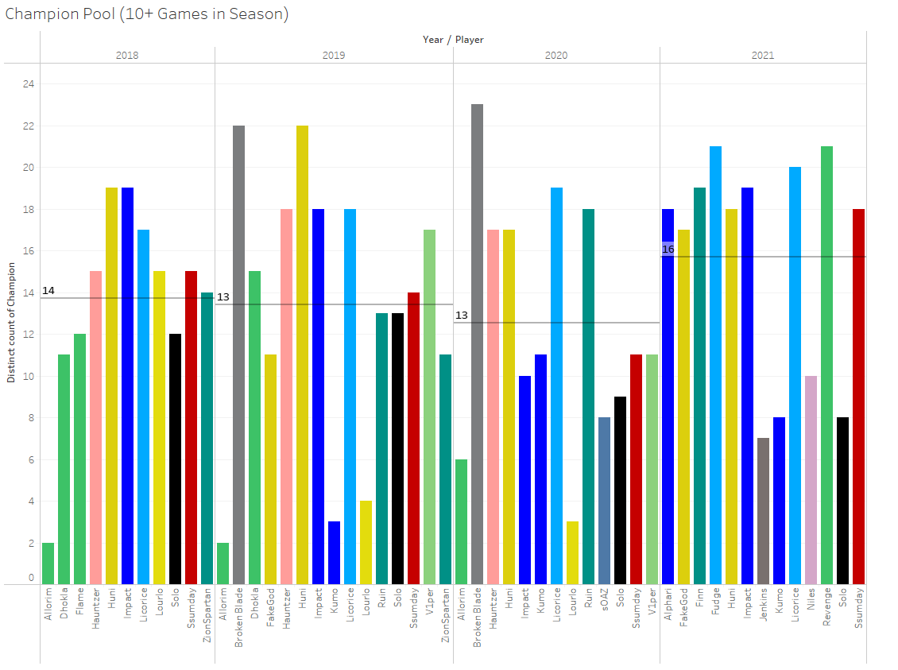

In comparison to other toplane players, Solo has a fairly small champion pool. You can see here that he tends to be below average in the number of different champions he plays in a split. There can be a lot of reasons for this, mostly based on how his teams want to play, and how his teams want to draft. If Solo’s team needs a stable topside, they’re going to want him to play a bruiser or teamfighter.

|  |  |  |
| --- | --- | --- |
|  |  |  |
| Champion | Games | PlayRate |
| Ornn | 23 | 14% |
| Aatrox | 21 | 13% |
| Gangplank | 20 | 12% |
| Gnar | 13 | 8% |
| Sett | 13 | 8% |

Table 2: Solo Champ Pool and Play Rate (Patch > 8.01)

Solo’s top 5 most played champions is about what I would expect for someone who doesn’t play a wide variety of champions. It’s the most popular toplane tank (Ornn), a set of bruisers (Aatrox, Sett, Gnar) and a versatile blind-pickable carry (Gangplank). This is a pretty standard collection of top lane champions though notably, it lacks any sort of splitpush hardcarry. No Camille, or Jayce, and Renekton doesn’t even make his top 5. **This probably explains why his DamageTaken is almost 10% higher than the average. Bruisers have large health pools, and their jobs are to absorb damage, so Solo is going to be soaking damage on the frontline more than players who are more likely to be put on high damage champions.**

Additionally, I would wager that Solo rarely gets draft resources from his teams in champ select, nor does he get jungle resources in game. Many of these champs are blind-pickable in LCS meaning that they are difficult to hard-counter without heavy commitment from the other team. Many of these champions would either be a first pick on blue side so as to not give anything away in the draft, or a R3/R4 pick on red side because they are not likely to be counterpicked. That will come later though, I want to do a bit more of an explanation of Solo’s champion pool against the field.

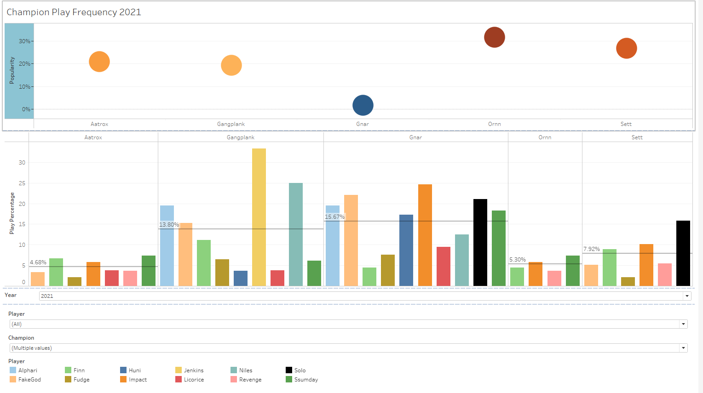

I put together this dashboard to highlight champion play rate tendencies against popularity. The top chart shows how popular the champion was with popularity being defined as their overall pick rate in top lane by year. The bottom chart shows the pick rate of each champion by the players as well as the average player pick rate. The side chart gives a breakdown of which champions each player played and how often in each year.

If a champion is very popular in the top chart that means one of two things. Either teams really want to play it and they pick it early, or it means that it is very safe and you can blind pick it or pick it into a wide variety of champions. That determination will probably have to be made from watching games, but we don’t need it for this part of the analysis.

What I wanted to learn here was whether Solo plays his “favorite” champions at a much higher rate than other top laners, or if he is just playing the high pick rate champions along a particular axis (the best bruiser, the best tank, the best fighter, etc.).

From examining the data, here are some things I learned. Rounding down to the nearest whole champion, Solo is always on the side of having a smaller champion pool than the average top laner.

|  |  |  |
| --- | --- | --- |
| Year | Top Avg Champion Pool* | Solo Avg Champion Pool |
| 2018 | 14 | 12 |
| 2019 | 14 | 13 |
| 2020 | 12 | 9 |
| 2021 | 15 | 8 |

*Excludes players with 2 or fewer games that year

Table 3: Champ Pool Size

Taking 2020 as an example, the top 5 most popular champions were Ornn, Aatrox, Sett, Gangplank, and Renekton. Solo Played Ornn and Sett well above average, and Renekton/Aatrox below average. In a field of bruisers, Solo’s most played champion was a tank, and he played it a disproportionate amount of the time.

In 2019 the top lane pool was almost exclusively high damage carries with one exception. Aatrox, a sustained damage bruiser was the highest presence champion and Solo played it in a third of his games.

Overall, Solo seems to gravitate towards whatever the tankiest option is or Gangplank. He actually plays Gangplank at an above average rate for 3 of his 4 years as a professional player.

**After looking at his champion pool and play rates, I believe that Solo is almost exclusively used as a weak side tank player by his teammates. His job is to absorb jungle pressure and initiate teamfights. When he is forced to blind pick a champion, which I suspect is frequently, he chooses the most popular bruiser, or Gangplank.**

When I look at champion select in Solo’s games, here’s what I’m expecting to see:

1. On blue side, which has first pick, he will be given second/third pick because his team will want to get him one of his priority champions and save what counter picks they have available for other lanes.
2. On red side, he will be either ½ for the reason stated above, or he will receive 4th pick because his team will want to save their counterpick option for a different lane.

2018: